Ear Infection

**An ear infection is an infection of the middle ear, the air-filled space behind the eardrum that contains the tiny vibrating bones of the ear. Children are more likely than adults to get ear infections.**

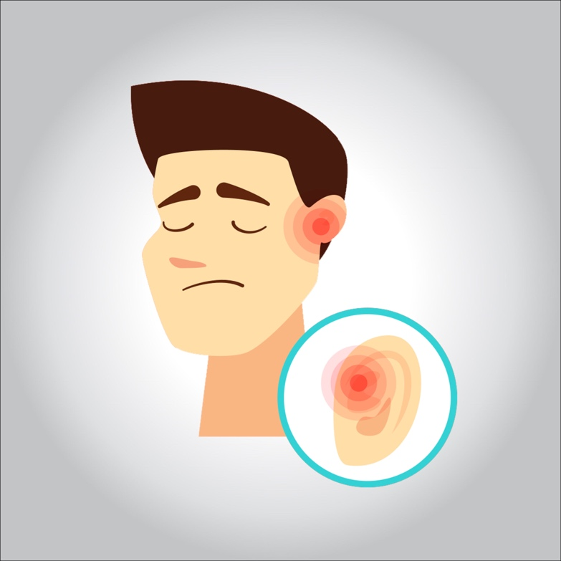

**Because ear infections often clear up on their own, treatment may begin with managing pain and monitoring the problem. Sometimes, antibiotics are used to clear the infection. Some people are prone to having multiple ear infections. This can cause hearing problems and other serious complications.**

**Treatment**

* **Pain medication . Anesthetic drops**